Software Engineering Department

Braude College of Engineering, Karmiel



Capstone Project – Phase A (61998)



**RoadSenseAI**

Collaborative Pothole Detection and Mapping

26-1-D-9

**Student 1:** Noa Sivan (209090034)

**Student 2:** Eden Kantor (316138403)

**Advisor:** Gur Arye Yehuda

**GitHub Repository:** <https://github.com/EdenKantor/RoadSense-AI-Hazard-Detection.git>

**Table of Contents**

1. Abstract 3

2. Introduction 3

2.1 Background and Motivation 3

2.2 Problem Statement 3

2.3 Project Goal 3

2.4 Proposed Solution (High-Level Overview) 4

2.5 Scope and Assumptions (MVP) 4

3. Literature Review 4

3.1 Theoretical Background 4

3.1.1 Pothole Monitoring and Crowdsourcing 4

3.1.2 Computer Vision for Pothole Detection 5

3.1.3 YOLO-Based Object Detection 6

3.1.4 From Detections to Geospatial Pothole Events 7

3.1.5 Web Mapping and Decision Support Visualization 8

3.2 Technologies and Implementation Considerations 8

4. Development Plan 9

4.1 Functional Requirements 9

4.2 Non-Functional Requirements 10

4.3 Requirements Gathering 11

4.4 Development Process 12

4.5 Expected Challenges and Mitigation Strategies 13

4.6 Tools and Technologies 14

4.7 System Overview and Architecture 15

4.7.1 Logical Architecture (Package Diagram) 16

4.7.2 Runtime Workflow (Activity Diagram) 17

4.8 Success Metrics 18

4.9 Testing Process 19

5. AI Tools and Prompts 20

6. References 21

# 1. Abstract

Potholes pose safety risks, cause vehicle damage, and increase maintenance costs. Existing municipal inspection and reporting practices often provide limited coverage and delayed, inconsistent information about defect locations and resolution status. RoadSenseAI proposes a collaborative platform that transforms citizen trip recordings into a shared pothole map and an authority-facing workflow for tracking maintenance progress. In the MVP, citizens upload standardized trip artifacts (MP4 video and GPX telemetry) via a web portal, and the backend processes uploads asynchronously to generate geolocated pothole events. These events are visualized on an interactive map for public awareness and are managed by authorized staff through lifecycle status updates.

# 2. Introduction

## 2.1 Background and Motivation

Maintaining road infrastructure is an ongoing operational challenge for municipal authorities. Road surfaces degrade over time due to traffic loads and environmental conditions, and potholes may emerge rapidly, particularly during seasonal transitions. For drivers, these hazards pose immediate safety risks and can result in vehicle damage. For authorities, reliance on fragmented and delayed information combined with limited geographic coverage makes it difficult to maintain an accurate operational picture and to track repair resolution consistently. This gap between defect formation and maintenance action motivates the need for a more systematic and timely reporting process.

## 2.2 Problem Statement

Current approaches for identifying and managing potholes rely primarily on manual citizen reporting and periodic inspections. These methods often provide limited geographic coverage, inconsistent report quality, and significant latency between defect formation and repair. As a result, authorities may lack a timely operational picture of pothole distribution and urgency, while citizens have limited visibility into what is being addressed.

## 2.3 Project Goal

RoadSenseAI aims to implement an end-to-end MVP that converts crowdsourced trip recordings into structured information that can support maintenance decision-making. The system’s objectives are twofold: (1) to provide citizens with a shared map-based view of detected and consolidated pothole events, and (2) to provide authorities with an operational dashboard that organizes events as actionable items and supports lifecycle status tracking throughout the handling process.

## 2.4 Proposed Solution (High-Level Overview)

RoadSenseAI is a collaborative platform that translates citizen-collected trip recordings into a shared, map-based view of road hazards. The system serves as a web-based intermediary between citizens and authorities: it ingests trip data submitted by users and produces consolidated hazard events that can be explored publicly and managed operationally. By shifting from purely manual reporting to a semi-automated workflow, the platform aims to improve coverage, consistency, and visibility of road maintenance needs for both the public and municipal stakeholders.

## 2.5 Scope and Assumptions (MVP)

The MVP focuses on an offline reporting workflow based on uploaded trip artifacts. The scope includes (1) a citizen-facing upload and tracking experience, (2) server-side hazard analysis, and (3) an authority-facing interface for monitoring and updating event status.

**Assumptions and limitations:**

* **Target defect:** The initial scope focuses on potholes; other defect types (e.g., cracks, debris) are excluded.
* **Processing mode:** Analysis is performed post-trip (not real-time during driving).
* **Input format and quality:** The system assumes inputs are provided as MP4 video and a time-stamped GPX track captured using consumer devices under reasonable recording conditions.

# 3. Literature Review

## 3.1 Theoretical Background

This section reviews the core concepts that underpin end-to-end pothole mapping systems. The discussion is organized around five pillars: (1) crowdsourced road monitoring and operational reporting practices, (2) challenges of pothole perception in real-world driving video, (3) one-stage object detection and YOLO-based benchmarking considerations, (4) conversion of frame-level detections into stable geospatial events through time location alignment and spatial aggregation, and (5) scalable web mapping patterns that support public visibility and authority-oriented decision workflows.

### 3.1.1 Pothole Monitoring and Crowdsourcing

Road defect management is traditionally performed through scheduled field inspections, contractor feedback, and citizen complaints. Although manual inspection methods (e.g., windshield surveys) enable expert assessment, they are labor-intensive and may suffer from subjectivity and limited temporal coverage. As a result, defects can remain undetected for extended periods, increasing the delay between damage formation and repair. [Eriksson et al., 2008]

Crowdsourcing based on participatory sensing offers a scalable alternative by leveraging routine trips to increase spatial coverage and reporting frequency, reducing dependence on manual surveys. This approach has been explored in early mobile sensing systems for road monitoring, demonstrating the feasibility of collecting roadway signals at scale. [Eriksson et al., 2008], [Mohan et al., 2008].

However, crowdsourced reporting introduces reliability challenges, including duplicate observations of the same defect, noisy or sparse location samples, and variability in sensor viewpoint and capture conditions. Therefore, recent end-to-end monitoring frameworks emphasize the need for validation and traceability mechanisms (e.g., preserving upload metadata and maintaining an auditable event lifecycle) to support operational decision-making by authorities. Figure 1 provides an example participatory sensing architecture for road monitoring from prior work [Eriksson et al., 2008].

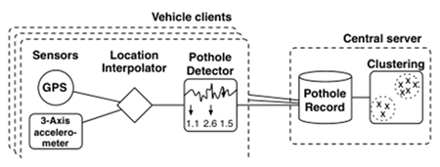

*Figure 1: Example participatory sensing architecture for road-anomaly monitoring (vehicles upload sensed data to a central server for aggregation)* *[Eriksson et al., 2008]**.*

### 3.1.2 Computer Vision for Pothole Detection

Pothole detection in real driving video is challenging because road defects are often visually subtle and strongly affected by acquisition conditions. Potholes can be treated as “negative obstacles”, where detectability relies on weak contrast and texture cues rather than clear object boundaries. As a result, performance degrades under motion blur, viewpoint changes, and partial occlusions. Moreover, illumination variability (e.g., tree shadows, glare) and wet/reflective asphalt can both suppress defect appearance (missed detections) and introduce misleading patterns (false positives). Consequently, prior work emphasizes evaluation under diverse environmental conditions and the inclusion of hard negative samples (e.g., manholes, patches) to improve robustness and reduce false alarms. [Bučko & Lieskovská, 2022], [Safyari et al., 2024] Figure 2 outlines a typical end-to-end vision pipeline used for pothole detection in driving footage.

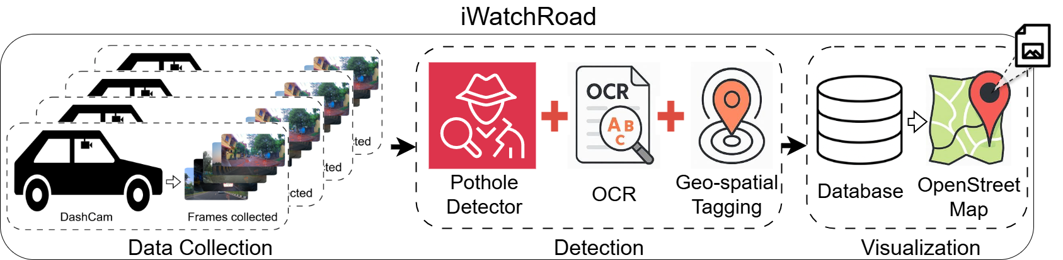

*Figure 2: End-to-end dashcam pothole detection pipeline (collection → detection → geo-tagging → visualization)* *[Sahoo et al., 2025a]**.*

### 3.1.3 YOLO-Based Object Detection

Driving-footage analysis requires a practical balance between inference latency and detection accuracy. Benchmarking studies highlight the inherent speed–accuracy trade-off across detector families, motivating the use of efficient one-stage detectors in near real-time settings [Huang et al., 2017]. Recent YOLO benchmarks further indicate that YOLOv8 improves accuracy over YOLOv5 at comparable throughput, while YOLOv7 tends to be more accurate but slower (Figure 3) [3].

**Note:** Although newer versions (e.g., YOLOv11) exist, YOLOv8 was selected for its proven stability and mature ecosystem, prioritizing reliability over marginal performance gains.

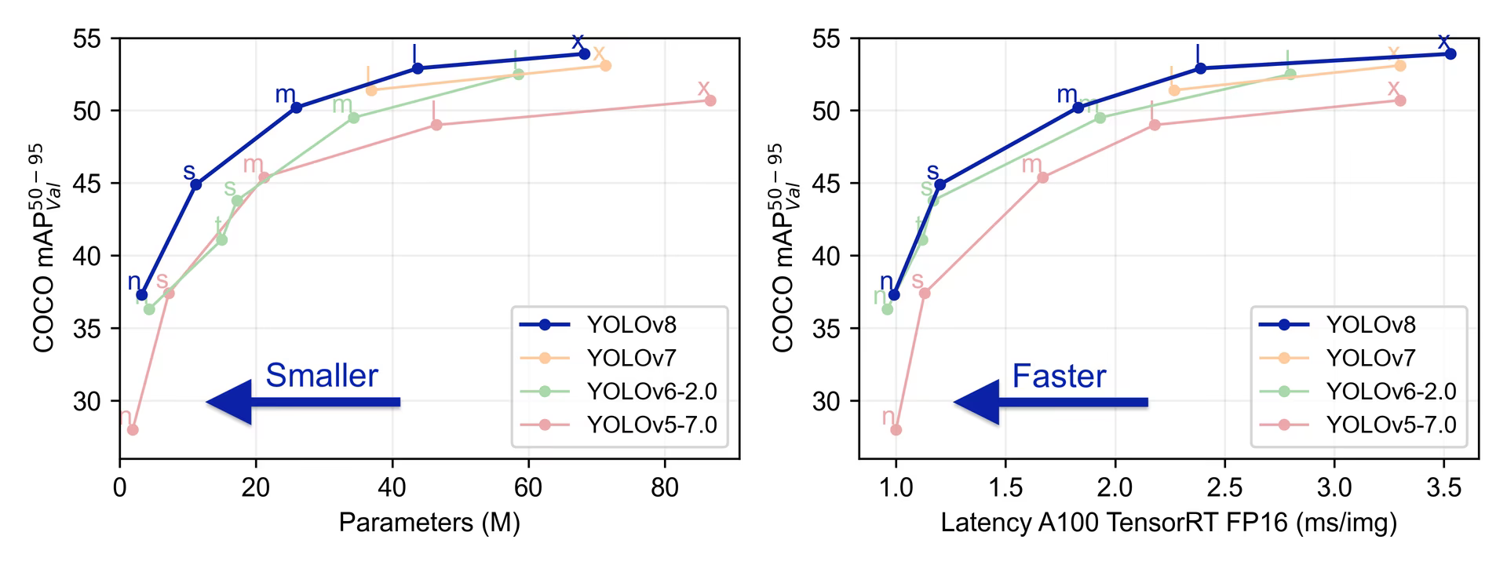

*Figure 3: YOLOv8 model-family trade-off between speed and accuracy across different model sizes* *[3]**.*

As illustrated, YOLOv8 is frequently selected in recent YOLO surveys due to design choices such as its anchor-free formulation, which is well-suited for objects with significant scale variation, including road-surface defects [Terven et al., 2023],[Reis et al., 2023].  
YOLO models output a confidence score for each predicted bounding box. Selecting a confidence threshold directly controls how many detections are accepted: higher thresholds reduce false alarms but may miss small or difficult potholes. Figure 4 shows a representative detection output with confidence scores, which are filtered during inference based on the chosen threshold.

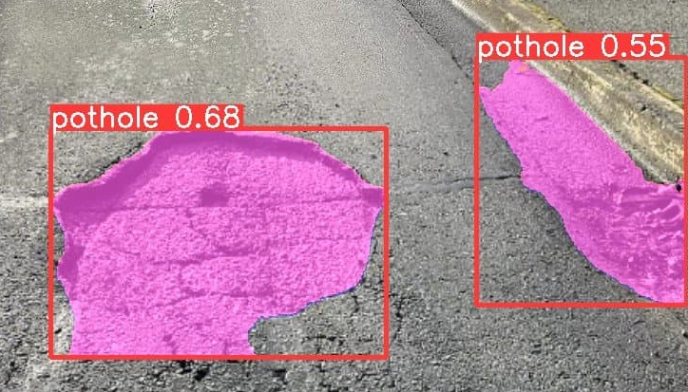

*Figure 4: Example object-detection output with confidence scores, illustrating how detections are filtered by a confidence threshold* [1]*.*

In addition, overlap handling is essential in object detection. Intersection-over-Union (IoU) is used both for evaluation and for non-maximum suppression (NMS), which removes duplicate overlapping boxes for the same object. Figure 5 visualizes IoU conceptually.

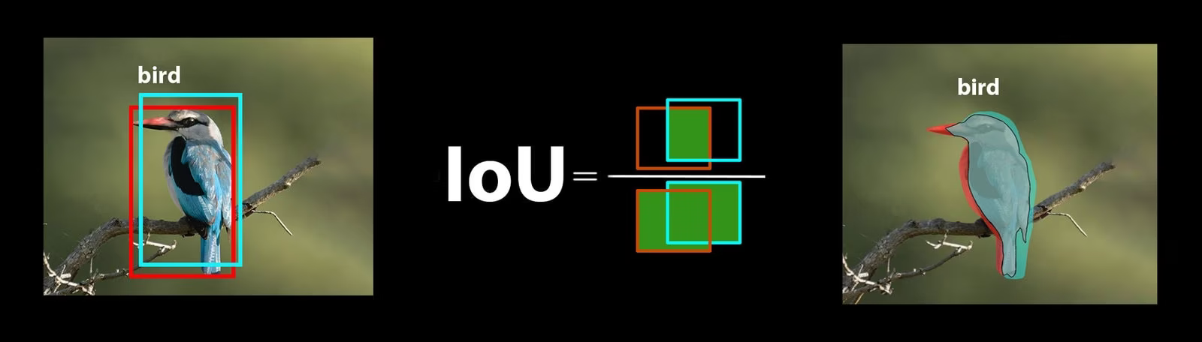

*Figure 5: Intersection-over-Union (IoU) concept used for evaluation and for overlap-based suppression during post-processing (NMS)* [4]*.*

### 3.1.4 From Detections to Geospatial Pothole Events

A core engineering challenge lies in converting high-frequency video detections into stable, unique map events. Because a single defect often appears across multiple consecutive frames, a naive pipeline would generate redundant markers for the same physical object. In addition, consumer-grade GNSS telemetry is sampled at a much lower rate than video and is subject to meter-level positioning errors, so repeated detections of the same defect may not share identical coordinates [Suzuki, 2023].

To bridge the temporal mismatch between video frames and location samples, systems typically geo-tag detections by combining frame timestamps with location metadata (e.g., GPS samples or other derived signals). After geo-tagging, spatial clustering can merge repeated detections into unique events; Figure 7 illustrates DBSCAN-style clustering behavior used conceptually for this purpose [Boumchich et al., 2022].

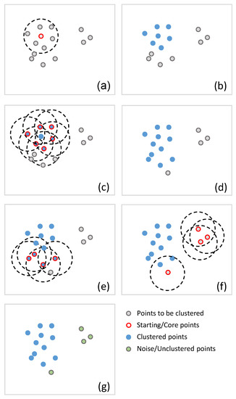

*Figure 7: Graphical representation of the DBSCAN procedure (ε-neighborhood expansion with MinPts) showing how clusters are grown and how noise points remain unclustered.* *[Boumchich et al., 2022]*

### 3.1.5 Web Mapping and Decision Support Visualization

Web mapping constitutes the primary interface for translating model detections into actionable information for end users and operational stakeholders. Prior work on browser-based mapping shows that large point datasets quickly create both visual clutter and performance bottlenecks. Nétek et al. demonstrate that marker clustering is an effective technique to preserve usability and rendering performance at scale [Nétek et al., 2019].

Beyond visualization, smart-city road monitoring platforms are commonly framed as operational decision-support tools, where the interface must support prioritization and workflow management rather than merely displaying markers [Sahoo et al., 2025a], [Sahoo et al., 2025b]. Accordingly, effective dashboards provide filtering by severity and lifecycle status, and support spatial retrieval of hazards within a defined area of interest (e.g., the current map viewport), enabling focused analysis and task handling [Sahoo et al., 2025a].   
Finally, the literature on citizen-centered reporting emphasizes the importance of transparent event lifecycle representation (e.g., Reported → In Progress → Closed) to “close the loop” between public submissions and authority action, which contributes to sustained engagement and trust [Sahoo et al., 2025a], [Santani et al., 2015]. Figure 8 illustrates how marker clustering improves readability by adapting to map zoom level.

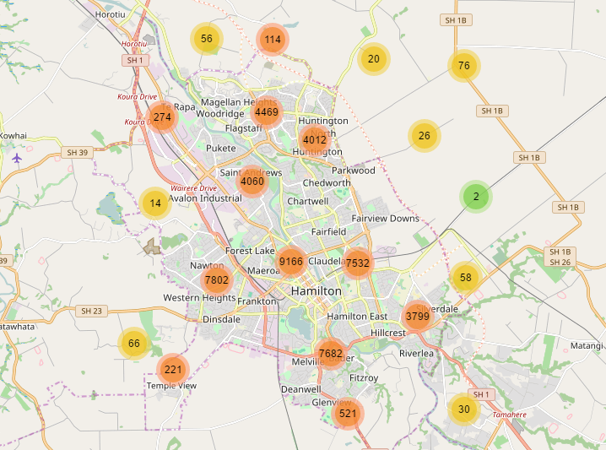

*Figure 8: Marker clustering in a web map (nearby markers are grouped into clusters at low zoom and split as the user zooms in)* *[2]**.*

## 3.2 Technologies and Implementation Considerations

RoadSenseAI follows a practical architecture designed to bridge the gap between computationally intensive video analysis and responsive user interaction. The implementation strategy decouples data ingestion from analysis to support scalability and maintain consistent system responsiveness.

**External Data Acquisition Strategy:** Instead of developing a proprietary recording module, the system adopts an open ingestion approach that accepts standardized MP4 video and GPX telemetry artifacts generated by external tools (e.g., Droid Dashcam). This decision reduces client-side complexity and ensures reproducible inputs, allowing development effort to focus on the analytical pipeline and system integration rather than mobile sensor management.

**Asynchronous Decoupling for High Availability:** A key implementation concern is the mismatch between short-lived HTTP request cycles and long-running inference workloads. To address this, the architecture uses asynchronous job execution: the API acknowledges uploads immediately and delegates heavy processing to background workers through a message broker. This separation keeps user-facing endpoints responsive even when multiple uploads are submitted concurrently.

**Efficiency in AI Inference:** The processing pipeline is designed with throughput as a primary objective, using an efficient object detection workflow suitable for driving footage. Model optimization and domain adaptation (e.g., dataset-specific evaluation and optional fine-tuning) are treated as iterative improvements aimed at reducing false positives under real-world conditions such as shadows, reflections, and road texture variation.

**Geospatial Data Management:** Road hazards require spatial retrieval and consolidation rather than purely relational access. The data layer uses geo-indexed storage to support efficient server-side queries and event consolidation (e.g., merging proximate detections using a configurable radius). On the visualization layer, client-side marker clustering is applied to reduce map clutter and preserve interactive performance as the dataset grows.

# 4. Development Plan

## 4.1 Functional Requirements

|  |  |
| --- | --- |
| **ID** | **Requirement** |
| FR-1 | The system shall allow a citizen to upload a trip video (MP4) and a GPS log (GPX) via the web portal. |
| FR-2 | The system shall provide the citizen with an immediate upload acknowledgment and a real-time tracking status. |
| FR-3 | The system shall store upload metadata, including uploader identity, timestamps, and current processing status. |
| FR-4 | The system shall asynchronously process each uploaded trip to detect potholes and generate geospatial pothole events. |
| FR-5 | The system shall associate pothole detections with geographic coordinates using timestamp-based alignment between processed frames and GPS samples. |
| FR-6 | The system shall merge repeated and nearby detections into a single pothole event to reduce duplicate map entries. |
| FR-7 | The system shall estimate and store a severity level for each pothole event using a defined heuristic. |
| FR-8 | The system shall provide a shared map view that displays pothole events. |
| FR-9 | The system shall allow users to filter pothole events on the map by severity. |
| FR-10 | The system shall allow users to filter pothole events on the map by lifecycle status. |
| FR-11 | The system shall reduce visual overload in dense areas by aggregating nearby pothole markers into clusters at low zoom levels. |
| FR-12 | The system shall provide a personal upload history view that lists the citizen’s submitted trips and their processing results. |
| FR-13 | The system shall provide an Authorities dashboard that lists pothole events as actionable tasks. |
| FR-14 | The system shall allow authorized authority users to update an event lifecycle status. |
| FR-15 | The system shall enforce Role-Based Access Control to restrict administrative actions to authorized personnel. |
| FR-16 | The system shall support area-based queries to retrieve pothole events relevant to the current map viewport. |
| FR-17 | The system shall allow an admin to approve or verify authority accounts before granting authority permissions. |

## 4.2 Non-Functional Requirements

|  |  |  |
| --- | --- | --- |
| **ID** | **Category** | **Non-Functional Requirement** |
| NFR-1 | Performance | The system shall support concurrent video uploads from at least 20 users simultaneously without degradation of service availability. |
| NFR-2 | Performance | The asynchronous processing shall complete within 5 minutes for a 1-minute 1080p video on the project’s target machine. |
| NFR-3 | Performance | The map view shall render pothole markers and clusters within 2 seconds after a viewport change (pan/zoom). |
| NFR-4 | Performance | Geospatial queries for retrieving events within map bounds shall execute in less than 500 ms on the database side under normal load. |
| NFR-5 | Reliability | The web portal shall handle upload/network errors by notifying the user and allowing a retry without corrupting stored upload data. |
| NFR-6 | Reliability | The backend components (API and database) shall be available 99.0% of the time during business hours. |
| NFR-7 | Reliability | The system shall ensure data integrity so that no collected GPS samples or video frames are lost during the alignment process. |
| NFR-8 | Security | The system shall enforce server-side authorization so that only users with the Authority role can access authority endpoints and update report statuses. |
| NFR-9 | Security | Sensitive user data, such as passwords, shall be stored in the database using strong hashing algorithms. |
| NFR-10 | Usability | The system shall automatically cluster nearby markers when the viewport contains more than 100 events to reduce visual clutter. |
| NFR-11 | Usability | The web portal shall provide clear, consistent navigation across portals (Citizen/Authority/Admin) and present role-appropriate actions only. |
| NFR-12 | Usability | The system shall provide visual feedback for user actions, such as progress bars or status updates, within 1 second of the event. |
| NFR-13 | Accuracy | The pothole detection algorithm shall achieve a Precision of at least 80% (confidence > 0.6) on the test dataset, prioritizing the minimization of false positives. |
| NFR-14 | Accuracy | The geospatial merging logic shall successfully combine events located within 5 meters of each other with a 95% success rate to prevent map duplicates. |

## 4.3 Requirements Gathering

RoadSenseAI requirements were elicited using a mixed methodology that combines (i) analysis of end-to-end road-damage monitoring pipelines, (ii) computer-vision evaluation practices and common failure modes, and (iii) principles from crowdsourced reporting and web-mapping scalability. In addition, we performed scenario walkthroughs aligned with the intended user roles (Citizen, Authority, Admin) to translate research patterns into actionable system requirements.

**Pipeline-driven requirements (system workflow):** We reviewed reference architectures that describe a complete operational chain: trip data acquisition, frame extraction, pothole detection, geo-association, and map-based presentation. These patterns motivated core functional requirements such as: ingesting synchronized MP4+GPX inputs, executing inference asynchronously (to avoid blocking the API), generating geospatial events from frame-level detections, and exposing results through a map dashboard (e.g., iWatchRoad) [Sahoo et al., 2025a],[Sahoo et al., 2025b].

**Computer vision and validation requirements:** We derived CV-oriented requirements from the literature on pothole detection, with emphasis on known sources of error (illumination changes, motion blur, occlusion, and confusing road artifacts). This informed requirements for post-processing, confidence-based filtering, and measurable evaluation using standard object-detection metrics and terminology [Lin et al., 2014],[Safyari et al., 2024].

**Data quality, reliability, and governance:** Because RoadSenseAI aggregates user-contributed observations, we incorporated requirements that support traceability and reliability, such as preserving provenance (upload metadata), enabling verification workflows, and applying deduplication to reduce noisy or repetitive reports. These requirements are consistent with findings from crowdsourced hazard-reporting systems and research on reliability mechanisms and source credibility [Santani et al., 2015],[Mihelj et al., 2019].

**Visualization and scalability requirements:** Finally, to ensure the map remains usable at scale, we adopted requirements for efficient rendering and decluttering strategies. Prior comparative studies of web-mapping visualization techniques support the need for marker clustering (especially at low zoom levels) to avoid browser overload and improve readability, motivating our dashboard-level clustering strategy [Nétek et al., 2019].

## 4.4 Development Process

The project follows an Agile development approach organized into two-week sprints. The roadmap is structured into seven milestones, progressing from infrastructure setup to end-to-end integration and evaluation.

**Sprint 1:** System Initialization

* Establish version control (Git) and development environments.
* Set up the React web client skeleton (routing, page layout, basic UI components).
* Deploy a minimal FastAPI backend with a basic health endpoint and project structure.
* **Deliverable:** running frontend + backend skeleton with development workflow in place.

**Sprint 2:** Data Ingestion Baseline (MP4 + GPX)

* Define the upload format and storage structure for MP4 and GPX artifacts (file system + metadata records).
* Implement the upload endpoint in FastAPI (store raw files, create an upload record with status).
* Implement initial parsing utilities for GPX and extraction of basic video metadata.
* **Deliverable:** end-to-end upload flow that stores artifacts and creates an upload entry (“Queued”).

**Sprint 3:** Asynchronous Processing Infrastructure (Redis + RQ)

* Integrate Redis and RQ to support background job execution.
* Implement job lifecycle states (Queued → Processing → Done/Failed) and status endpoint.
* Implement a basic worker pipeline stub (load inputs, run a placeholder job, persist status updates).
* **Deliverable:** stable asynchronous processing framework supporting concurrent uploads without blocking the API.

**Sprint 4:** Computer Vision Pipeline Integration (YOLOv8 Baseline)

* Integrate YOLOv8 inference into the worker (frame sampling strategy, confidence thresholding, output schema).
* Persist raw detections and intermediate outputs for debugging and evaluation.
* Define a preliminary relative severity heuristic (e.g., confidence + bounding box characteristics).
* **Deliverable:** The worker produces consistent detection outputs from uploaded videos.

**Sprint 5:** Geospatial Alignment and Event Consolidation

* Implement time alignment between detections and GPX samples (timestamp-based association + interpolation when required).
* Apply DBSCAN clustering to merge spatially proximate detections into unique road events.
* Persist final events in MongoDB using a map-friendly schema (GeoJSON + attributes).
* **Deliverable:** transformation from raw detections into consolidated geospatial events ready for visualization.

**Sprint 6:** Web Portal Features and Role-Based Access

* Implement authentication and authorization (JWT + roles: Citizen, Authority, Admin) and protected routes on the frontend.
* Citizen portal: upload history (“My Uploads”), status tracking, and public map view.
* Authority portal: task-style management of reports (status updates, filters, basic analytics).
* **Deliverable:** functional role-based platform with reporting lifecycle support.

**Sprint 7:** Final Integration, Validation, and Documentation

* End-to-end system validation (data capture → upload → processing → map visualization → status updates).
* Performance and robustness evaluation (processing time vs. video length, failure handling, basic scalability checks).
* Refactoring, code cleanup, and final documentation aligned with project deliverables.
* **Deliverable:** complete prototype ready for submission and demonstration.

## 4.5 Expected Challenges and Mitigation Strategies

Implementing the RoadSenseAI pipeline introduces technical challenges across computer vision, geospatial alignment, and system performance. This section outlines the main risks and the architectural strategies used to mitigate them.

**Computer Vision and Model Generalization:** A key challenge in vision-based pothole detection is reduced generalization when models are applied to road textures and lighting conditions that differ from their training data. To address this, YOLOv8 is used as the baseline detector, and the Road Damage Dataset (RDD) is selected as the primary domain dataset for evaluation and for planned fine-tuning in later iterations. In addition, the pipeline includes confidence filtering and post-processing to reduce false positives caused by common road artifacts (e.g., shadows, manholes, and wet pavement). Since monocular video does not provide a reliable metric scale, the system reports a relative severity level (Low/Medium/High) based on detection properties (e.g., bounding box size/consistency) as a prioritization heuristic rather than a physical measurement.

**Geospatial Precision and Time Alignment:** Consumer-grade GPS signals may exhibit drift, which can cause repeated detections of the same pothole to appear as multiple nearby markers on the map. To reduce map clutter, the system applies spatial clustering (DBSCAN) to consolidate proximate detections into unique road events. Another challenge is the mismatch between video sampling and GPX sampling rates. The pipeline aligns detections to geographic coordinates using timestamps from the video and GPX track, applying interpolation when required to estimate positions between recorded GPS points.

**System Scalability and Performance:** Deep learning inference is computationally intensive and can degrade API availability if executed synchronously during an upload request. To prevent request timeouts and maintain responsiveness under concurrent uploads, the architecture uses an asynchronous job queue (Redis + RQ). The API persists the uploaded artifacts and metadata, enqueues a background job, and returns immediately, while a worker process performs the analysis pipeline and updates the processing status and results in the database.

## 4.6 Tools and Technologies

The system is implemented as an asynchronous web-to-backend pipeline designed to remain responsive while executing computationally intensive video analysis.

**Presentation Layer (React & Leaflet):** Built as a Single Page Application (SPA) to support distinct user portals. Leaflet is integrated for efficient map rendering and optional marker clustering to visualize large numbers of road hazards. Usage: Provides the Citizen and Authority interfaces, handles file upload interactions, and renders the geospatial hazard map.

**Service Layer (FastAPI):** Selected for high performance and rapid development of REST APIs. The service remains responsive by delegating long-running video processing to background workers rather than executing inference within the HTTP request–response cycle. It also enforces payload validation using Pydantic schemas. Usage: Exposes REST endpoints, validates uploads, persists metadata, and enqueues processing jobs.

**Asynchronous Processing (Redis & RQ):** Provides job queueing and background execution to decouple the API from the inference pipeline. Redis buffers incoming jobs, and RQ workers consume and process them asynchronously. Usage: Queues upload jobs and dispatches video analysis tasks to the worker while keeping the API responsive under load.

**Computer Vision (YOLOv8):** Used as the object detection model for identifying road hazards on sampled video frames. YOLOv8 was selected as a suitable base model for domain adaptation using the RDD2022 dataset. Usage: Performs inference to generate bounding boxes and confidence scores for detected hazards.

**Data Persistence (MongoDB):** A NoSQL database used for storing metadata and processed reports. Its geospatial indexing enables efficient location-based queries (e.g., proximity search) directly in the database. Usage: Stores user profiles, upload records, and hazard reports, and supports map queries.

**Data Acquisition (Droid Dashcam):** An external tool used to capture synchronized MP4 video and GPX telemetry as the standardized system input. Usage: Generates raw trip artifacts (video + GPS track) for the analysis pipeline.

## 4.7 System Overview and Architecture

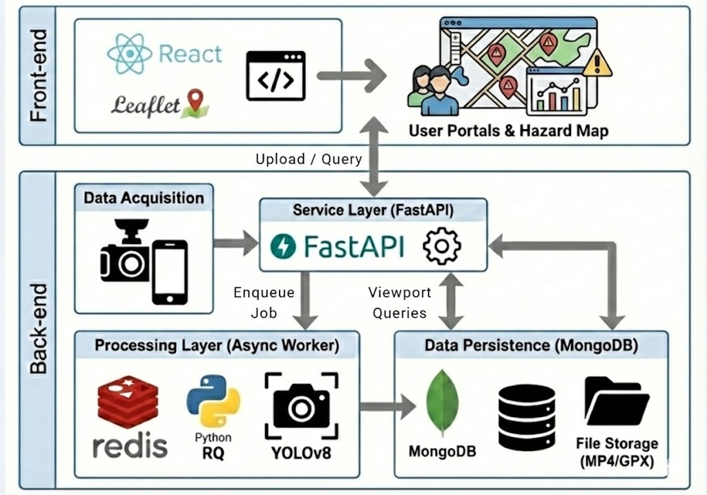

### 4.7.1 Logical Architecture (Package Diagram)

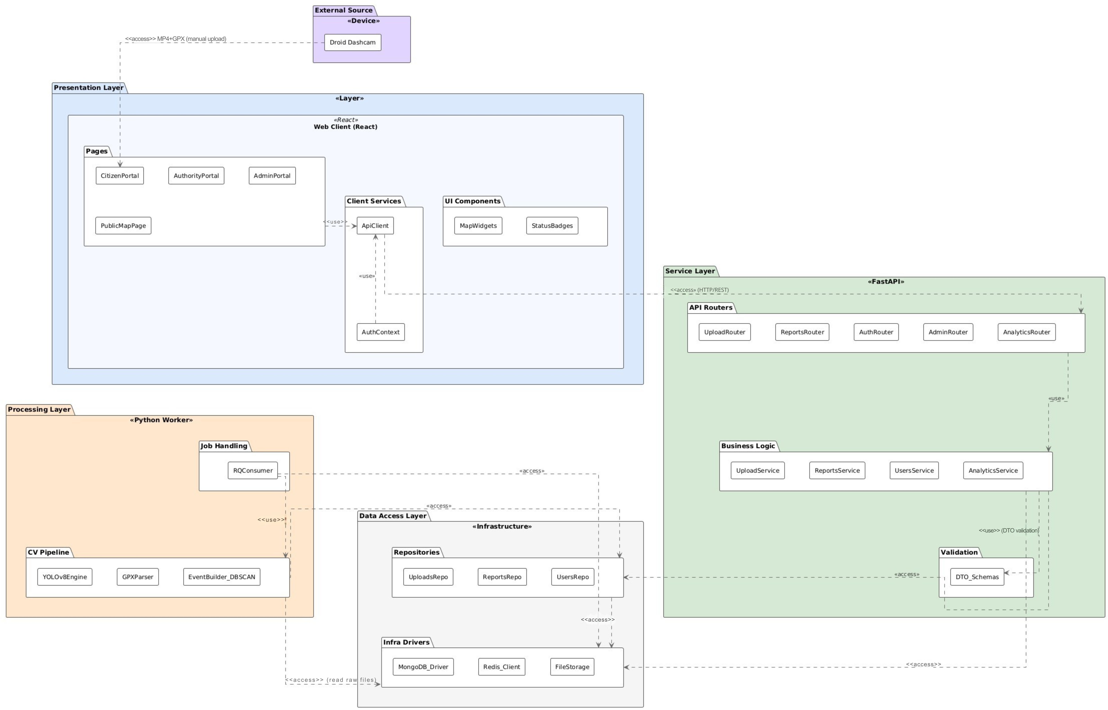

The Package Diagram provides a high-level logical view of RoadSenseAI and organizes the system into four layers with clear responsibilities and dependencies. The **Presentation Layer** is implemented as a React web client and contains the user-facing portals (Citizen, Authority, Admin) as well as a public map view. Client-side communication is centralized through an API client, and shared UI components are used to provide consistent map interaction and status representation.

The **Service Layer** (FastAPI) represents the synchronous entry point to the system. It exposes the REST API used by the web client, performs authorization checks, and coordinates the upload workflow. Importantly, this layer does not execute computationally intensive video analysis directly within the HTTP request. Instead, it prepares the required input artifacts and initiates background execution.

The **Processing Layer** is implemented as an RQ worker and is responsible for the heavy analysis pipeline. It consumes queued jobs, loads the uploaded MP4/GPX inputs, runs the detection stage (YOLOv8), associates detections with geospatial coordinates derived from the GPX track, and consolidates repeated detections into final road reports suitable for visualization and operational handling.

Finally, the **Data Access Layer** encapsulates the persistence and infrastructure mechanisms. MongoDB is used to store user information, upload metadata, and generate road reports; Redis serves as the job queue broker between the API and the worker; and file storage holds the raw MP4/GPX artifacts required for downstream processing.

### 4.7.2 Runtime Workflow (Activity Diagram)

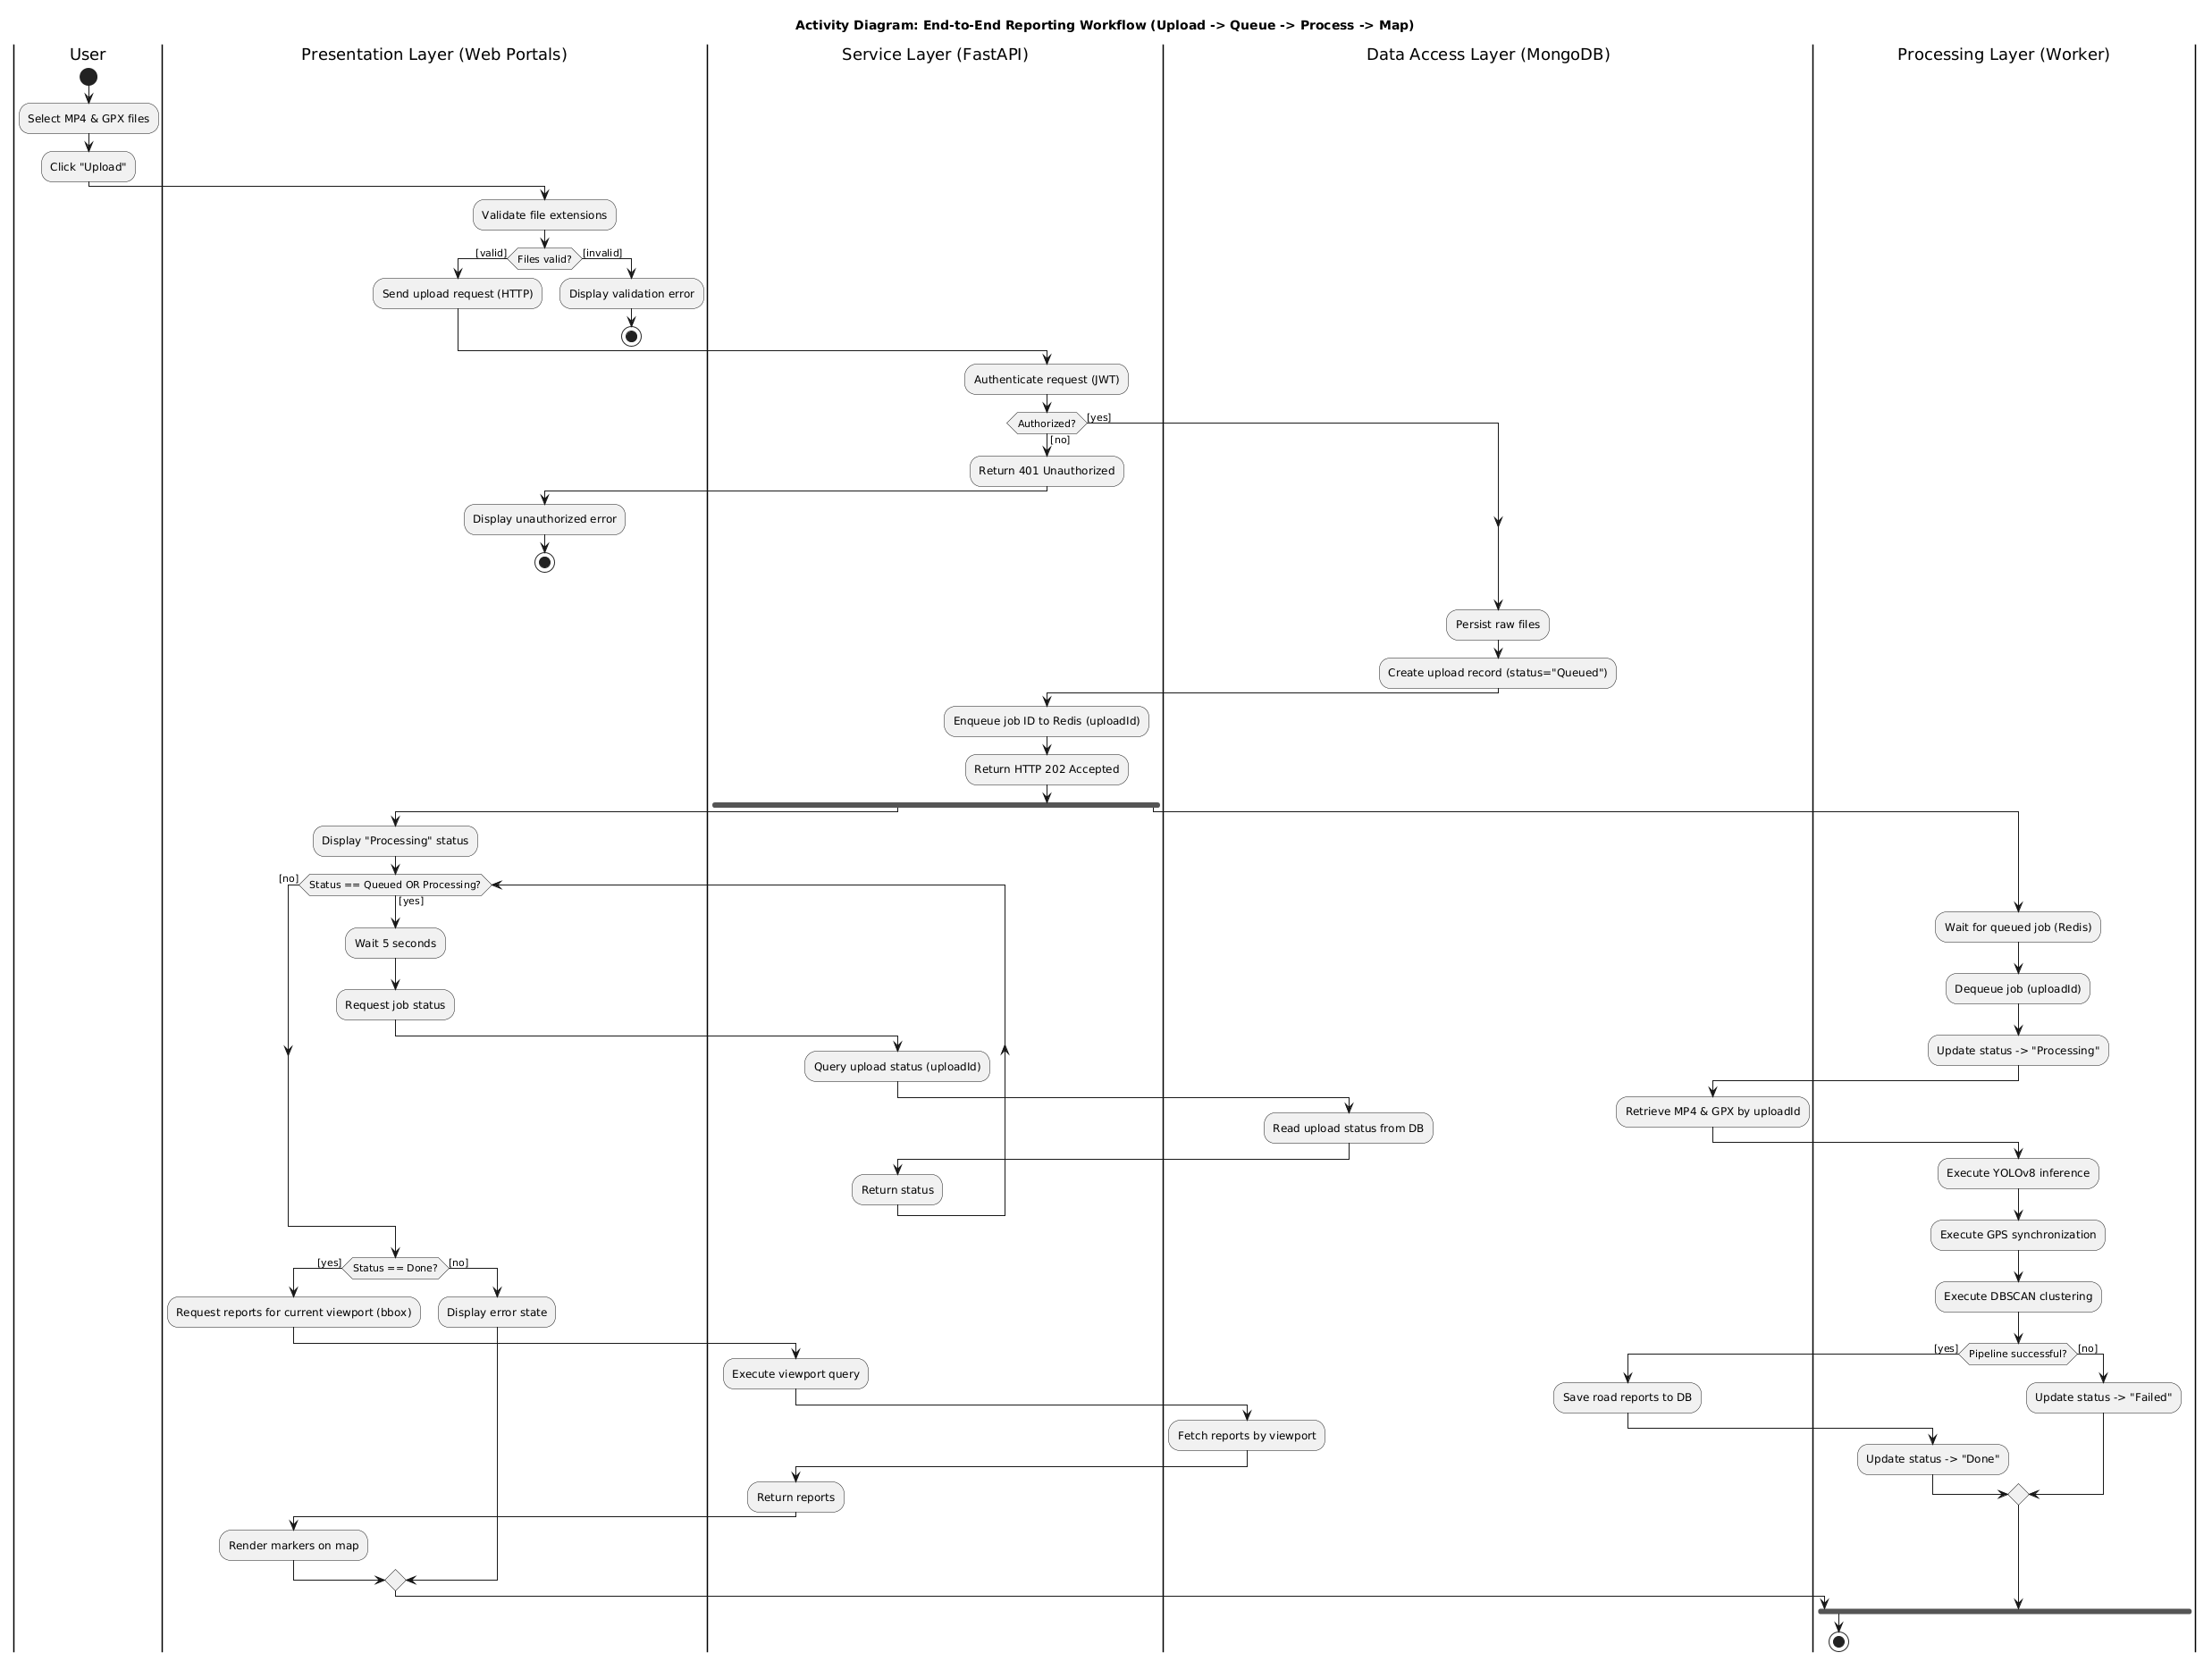

The Activity Diagram describes the end-to-end operational workflow of the system, from the moment a user submits an upload until the final results are displayed in the map interface. The workflow begins in the client, where the user selects an MP4 video file and a GPX track file and submits them through the web portal. The request is then handled by the backend, which verifies that the user is authorized, persists the raw files, and creates an upload record in the database with an initial status of Queued. The backend subsequently places a processing job (identified by the upload ID) into the Redis queue and returns HTTP 202 Accepted, allowing the client to continue without waiting for analysis completion.

After job submission, the workflow proceeds along two parallel paths. On the client side, the user interface displays a processing state and periodically queries the backend for the current status. In parallel, the background worker dequeues the job, updates the upload status to Processing, retrieves the raw MP4/GPX inputs, and executes the analysis pipeline. Upon completion, the worker stores the resulting road reports in the database and updates the status to Done or Failed. This status change terminates the client-side polling loop: in the successful case, the client retrieves the generated reports and visualizes them as map markers. otherwise, the client presents an error state indicating that processing did not complete successfully.

## 4.8 Success Metrics

To ensure RoadSenseAI meets its engineering and operational goals, we define quantitative Key Performance Indicators (KPIs). These KPIs will be measured during the final benchmark run and evaluated against the success thresholds in Table 4.8.  
Our KPI set is designed to answer five practical evaluation questions:

* How accurately does the system detect potholes in video frames? (KPI-1, KPI-2)
* How effectively does the system reduce duplicate detections into clean map events? (KPI-4)
* How fast does the system process an upload end-to-end? (KPI-3, KPI-5)
* How responsive is the map when users query and view hazards? (KPI-6)
* How reliably are detections assigned to geographic coordinates? (KPI-7)

Table 4.8: Success Metrics (KPIs)

| **KPI ID** | **Metric** | **Formula** | **Success target** |
| --- | --- | --- | --- |
| KPI-1 | Detection precision. Prevents flooding the map and authority queue with false events. | $$Precision = \frac{TP}{TP+FP}$$ | >= 0.80 |
| KPI-2 | Detection recall. Reduces missed potholes and improves safety coverage. | $$Recall = \frac{TP}{TP+FN}$$ | >= 0.70 |
| KPI-3 | Processing efficiency. Ensures the backend is efficient. The system must process video uploads faster than the playback time to handle scale. | $ProcRatio$ = $\frac{T_{finished} - T_{started}}{T_{video_duration}}$ | <= 1.0x |
| KPI-4 | Deduplication ratio. Validates the logical aggregation. Ensures that a continuous stream of detections (e.g., 30 frames of one pothole) is merged into a single map event. | *DedupRatio = $\frac{N_{rawDetections}}{N_{Events}}$* | >= 3:1 |
| KPI-5 | End-to-end latency. Ensures users receive a final outcome within a reasonable time window. | $$T_{total}= T_{Completion}-T_{upload}$$ | <= 5 min (1-min video) |
| KPI-6 | Map responsiveness. Keeps panning/zooming interactive for the end user (API round-trip time for a viewport query). | $T_{query}$ = *API round-trip time* | Avg <= 1 s, Max <= 2 s |
| KPI-7 | Geo-tagging validity. Ensures detections can be placed on the map and queried reliably. | GeoValidRate = $\frac{N_{geoTagged}}{N_{Events}}$ | >= 0.95 |

KPI-1 and KPI-2 are target thresholds inspired by the RDD2022 (CRDDC-2022) benchmark results reported in the literature, in our final evaluation we will follow the same protocol (IoU ≥ 0.5) and aim to reach comparable Precision/Recall levels [Arya et al., 2022].  
  
**Metric variables:** To keep the metrics easy to interpret, we use the following terms:

* TP (True Positives): potholes that the system detected and were confirmed as real.
* FP (False Positives): detections that turned out to be wrong (e.g., shadows or road markings).
* FN (False Negatives): real potholes that the system missed.
* $N_{rawDetections}$: the number of raw detections produced across video frames (before merging).
* $N_{Events}$*:* the final number of unique pothole events shown on the map after merging duplicates.
* $T_{finished} - T_{started}:$ How long does the worker need to process that video?
* $T_{upload}$: the time when the upload finishes.
* $T_{Completion}$: the time when processing finishes.
* $T_{query}$: the total time from requesting map data (for the current viewport) until the markers are displayed.
* $N_{geoTagged}$: number of detections that received a valid GPS coordinate.

## 4.9 Testing Process

Due to the iterative nature of our development process, we will design, implement, and test RoadSenseAI in three main modules: Upload & Backend API (FastAPI) – Processing Worker (YOLO + geo-tagging + aggregation) – Web Dashboard (React + Map).

* Upload & Backend API: We will validate the manual upload flow (MP4 + GPX), ensuring files and metadata are saved correctly and that the processing job is triggered.
* Processing Worker: We will test the core pipeline stages: frame sampling and detection, GPS alignment (geo-tagging), and deduplication/aggregation into final events.
* Web Dashboard: We will test the map experience (viewport queries, marker rendering, clustering) and the municipality workflow (status changes).

Table 4.9 summarizes the key tests and expected results.

|  |  |  |  |
| --- | --- | --- | --- |
| **Test** | **Module** | **Tested Function** | **Expected Result** |
| T-1 | Backend API | Manual upload (MP4+GPX) | Upload is accepted and stored successfully. |
| T-2 | Backend API | File validation | Invalid or missing MP4/GPX is rejected with a clear error. |
| T-3 | Backend API | Upload metadata | Upload record contains correct timestamps and file links. |
| T-4 | Worker | Frame sampling | Frames are sampled at the configured rate (e.g., ~1 FPS). |
| T-5 | Worker | YOLO detection | Potholes are detected and saved as raw detections. |
| T-6 | Worker | Geo-tagging (GPS alignment) | Each detection is assigned a valid GPS coordinate. |
| T-7 | Worker | Aggregation (dedup) | Multiple detections merge into a single map event. |
| T-8 | Database | Geo query by bounds | Query returns only events inside the viewport. |
| T-9 | Web Dashboard | Map load + markers | Map loads and displays events correctly. |
| T-10 | Web Dashboard | Clustering | Markers cluster on zoom-out and expand on zoom-in. |
| T-11 | authority Portal | Status workflow | Status changes are saved and reflected in the dashboard. |
| T-12 | End-to-End | Full pipeline | Uploads are processed within the KPI time target. |

# 5. AI Tools and Prompts

AI tools were used to accelerate writing and improve consistency across the report (e.g., requirements phrasing, KPI definitions, and testing descriptions). During the project, we used OpenAI ChatGPT (GPT models) and Google Gemini as writing assistants. The AI was used as a drafting assistant only. All generated content was reviewed, edited, and validated against the implementation and cited sources before inclusion.  
  
Examples of AI prompts that were used during development and writing:

* “Summarize the RoadSenseAI MVP in 120–150 words, emphasizing the collaborative map and the municipality workflow.”
* “Rewrite the Functional Requirements / Non‑Functional Requirements so they are measurable, concise, and aligned to the MVP scope.”
* “Propose quantitative Success Metrics (KPI formulas) for detection quality, aggregation quality, and map responsiveness.”
* “Draft a concise Testing Plan aligned with our KPIs, using short expected results and focusing on the most critical end-to-end tests.”
* “Suggest additional test cases for the Testing Process table (API failures, worker timeouts, geo-query performance, UI clustering).”
* “Draft an explanation of how confidence threshold and NMS affect false positives/false negatives in YOLO-style detectors.”
* “Provide a short, reader-friendly paragraph explaining how detections are aligned to GPS timestamps and merged into geo-events.”

# 6. References

## 6.1 Academic References

***[Arya et al., 2022]*** *Arya, D., Maeda, H., Ghosh, S. K., Toshniwal, D., Omata, H., Kashiyama, T., & Sekimoto, Y. (2022).* [*Crowdsensing-based Road Damage Detection Challenge (CRDDC’2022).*](https://arxiv.org/abs/2211.11362) *arXiv.*

***[Boumchich et al., 2022]*** *Boumchich, Y., Djeddou, M., & Boudani, M. (2022*).[*Using a Clustering Method to Detect Spatial Events in a Smartphone-Based Crowd-Sourced Database for Environmental Noise Assessment*](https://www.mdpi.com/1424-8220/22/22/8832). *Sensors, 22(22), 8832. DOI: 10.3390/s22228832.*

***[Bučko & Lieskovská, 2022]*** *Bučko, B., & Lieskovská, E. (2022).* [*Computer vision based pothole detection under challenging conditions. Sensors*](https://doi.org/10.3390/s22228878)*, 22(22), 8878.*

***[Eriksson et al., 2008]*** *Eriksson, J., Girod, L., Hull, B., Newton, R., Madden, S., & Balakrishnan, H. (2008).* [*The pothole patrol: Using a mobile sensor network for road surface monitoring*](https://doi.org/10.1145/1378600.1378605)*. In Proceedings of the 6th International Conference on Mobile Systems, Applications, and Services (MobiSys ’08). ACM.*

***[Huang et al., 2017]*** *Huang, J., Rathod, V., Sun, C., Zhu, M., Korattikara, A., Fathi, A., Fischer, I., Wojna, Z., Song, Y., Guadarrama, S., & Murphy, K. (2017).* [*Speed/accuracy trade-offs for modern convolutional object detectors. In Proceedings of the IEEE Conference on Computer Vision and Pattern Recognition (CVPR).*](https://arxiv.org/abs/1611.10012)

***[Lin et al., 2014]*** *Lin, T.-Y., Maire, M., Belongie, S., Bourdev, L., Girshick, R., Hays, J., Perona, P., Ramanan, D., Zitnick, C. L., & Dollár, P. (2014).* [*Microsoft COCO: Common objects in context*](https://arxiv.org/abs/1405.0312) *(arXiv:1405.0312).*

***[Mihelj et al., 2019]*** *Mihelj, J., Zhang, Y., Kos, A., & Sedlar, U. (2019*[*). Crowdsourced traffic event detection and source reputation assessment using smart contracts*](https://doi.org/10.3390/s19153267)*. Sensors, 19(15), 3267.*

***[Mohan et al., 2008]*** *Mohan, P., Padmanabhan, V. N., & Ramjee, R. (2008).* [*Nericell: Rich monitoring of road and traffic conditions using mobile smartphones*](https://doi.org/10.1145/1460412.1460444)*. In Proceedings of the 6th ACM Conference on Embedded Network Sensor Systems (SenSys ’08). ACM.*

***[Nétek et al., 2019]*** *Nétek, R., Brus, J., & Tomečka, O. (2019).* [*Performance testing on marker clustering and heatmap visualization techniques: A comparative study on JavaScript mapping libraries. ISPRS International Journal of Geo-Information*](https://www.mdpi.com/2220-9964/8/8/348)*, 8(8), 348.*

***[Reis et al., 2023]*** *Reis, D., Kupec, J., Hong, J., & Daoudi, A. (2023).* [*Real-time flying object detection with YOLOv8*](https://arxiv.org/abs/2305.09972) *(arXiv:2305.09972).*

***[Safyari et al., 2024]*** *Safyari, Y., Mahdianpari, M., & Shiri, H. (2024*[*). A review of vision-based pothole detection methods using computer vision and machine learning. Sensors*](https://www.mdpi.com/1424-8220/24/17/5652)*, 24(17), 5652.*

***[Sahoo et al., 2025a]*** *Sahoo, R. R., Mohanty, S. S., & Mishra, S. (2025).* [*iWatchRoad: Scalable detection and geospatial visualization of potholes for smart cities*](https://arxiv.org/abs/2508.10945) *(arXiv:2508.10945).*

***[Sahoo et al., 2025b]*** *Sahoo, R. R., Mohanty, S. S., & Mishra, S. (2025).* [*iWatchRoadv2: Pothole detection, geospatial mapping, and intelligent road governance*](https://arxiv.org/abs/2510.16375) *(arXiv:2510.16375).*

***[Santani et al., 2015]*** *Santani, D., Njuguna, J., Bills, T., Bryant, A. W., Bryant, R., Ledgard, J., & Gatica-Perez, D. (2015).* [*CommuniSense: Crowdsourcing road hazards in Nairobi.*](https://arxiv.org/abs/1506.07327) *In Proceedings of the 17th International Conference on Human-Computer Interaction with Mobile Devices and Services (MobileHCI ’15). ACM.*

***[Suzuki, 2023]*** *Suzuki, T. (2023).* [*Precise position estimation using smartphone raw GNSS data based on two-step optimization. Sensors*](https://www.mdpi.com/1424-8220/23/3/1205)*, 23(3), 1205.*

***[Terven et al., 2023]*** *Terven, J., Córdova-Esparza, D.-M., & Romero-González, J.-A. (2023).* [*A comprehensive review of YOLO architectures in computer vision: From YOLOv1 to YOLOv8 and YOLO-NAS. Machine Learning and Knowledge Extraction*](https://doi.org/10.3390/make5040083)*, 5(4), 1680–1716.*

## 6.2 Non-Academic References

***[1]***[*Viso.ai. “YOLOv8: The Ultimate Guide – Architecture and Features”*](https://viso.ai/deep-learning/yolov8-guide/)

***[2]*** MapTiler. “[Marker clustering with Leaflet](https://docs.maptiler.com/leaflet/examples/cluster/)”

***[3]*** Ultralytics. “[YOLOv8 Models](https://docs.ultralytics.com/models/yolov8/)”

***[4]*** [LearnOpenCV. “Intersection over Union (IoU) in Object Detection and Segmentation”](https://learnopencv.com/intersection-over-union-iou-in-object-detection-and-segmentation/)